

**KULLIYYAH OF INFORMATION & COMMUNICATION TECHNOLOGY**

**SEMESTER 2, 2018/2019**

**INFO 2103 Database Programming**

**SECTION 3**

**E-Book Library System (EXODUS)**

**PREPARED BY**

|  |  |
| --- | --- |
| **NAME** | **MATRIC NO.** |
| MUHAMAD ARIF LUTFI BIN AZIZ | 1315791 |
| MUHAMAD KHAIRUL AZMI BIN KHAIRUDIN | 1716803 |
| MUHAMMAD LUQMANULHAKIM BIN SA’ARI | 1813225 |
| AFIFI SYAHMI BIN KAMAL-LUDIN | 1710129 |
| ADAM IZZUDDIN BIN KHALID | 1627111 |

**LECTURER**

DR. ZAINATUL SHIMA ABDULLAH

**1.0 Introduction**

In the eras of modernization, digitization of anything physical has been trending for the last 2 decades. Starting from a very simple digitization of letter into messaging apps to a point where physical books are turned into digital books, or e-books (or electronic books). Having the scent of paper on physical books may seduce book lovers, but the advantages of e-books lies in their mobility, accessibility and the most importantly, their availability to the public masses as a free material. However, availability of these e-books were often abused, by merging other material into one another and discarding the copyright of the e-books and stripping their authors’ status of their work. Hence, our project, named as Exodus, focused on creating a database for managing all the e-books and exhibit all the advantages of e-books while still preserving its copyright and giving appreciation to authors for their work.

**2.0 Objective**

* To provide the simplest platform for the user to borrow and share book
* To have the community that love to read and learn stuff

**3.0 Conceptual Database Design**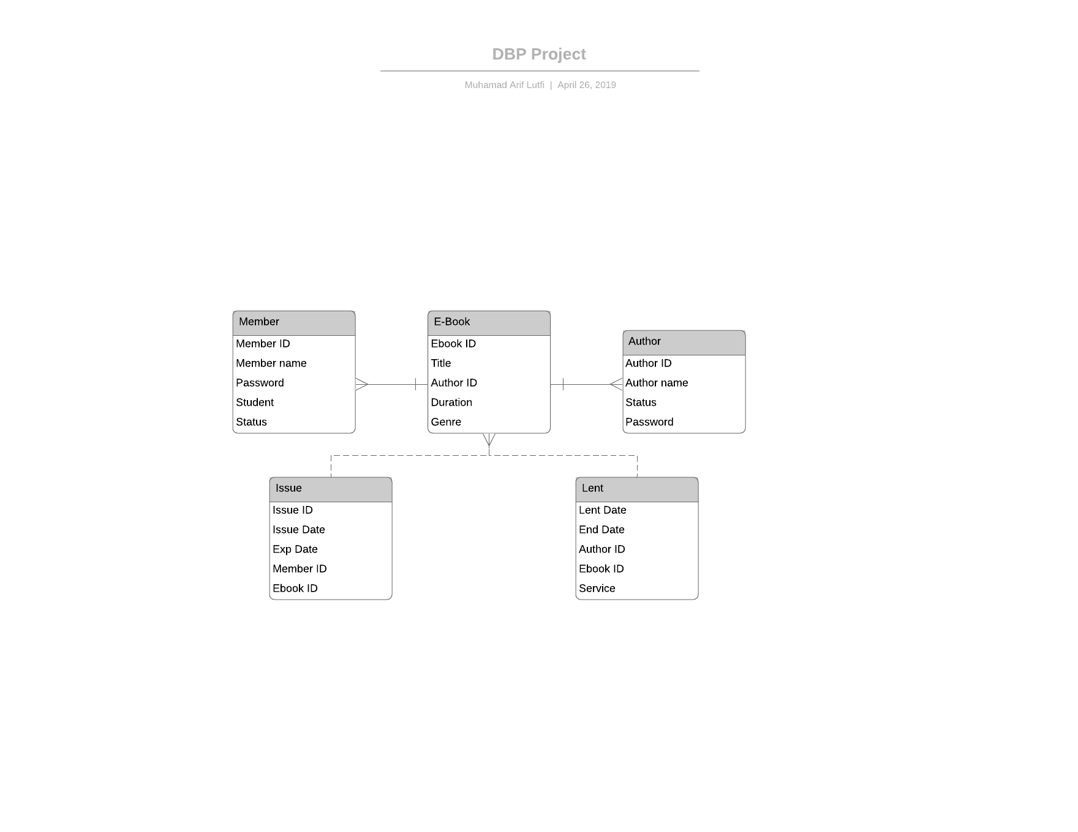

**4.0 Physical Database Design**

CREATE TABLE member (

memberid VARCHAR2(10) PRIMARY KEY,

membername VARCHAR2(30),

pswd VARCHAR2(8),

stud VARCHAR2(3),

status VARCHAR2(8));

-- TABLE AUTHOR ----------------------------------------

CREATE TABLE author (

authorid VARCHAR2(10) PRIMARY KEY,

authorname VARCHAR2(30),

pswd VARCHAR2(8),

status VARCHAR2(8));

-- TABLE EBOOK ------------------------------------------------------------

CREATE TABLE ebook (

ebookid VARCHAR2(10) PRIMARY KEY,

title VARCHAR2(50),

duration NUMBER(3),

genre VARCHAR2(30));

-- TABLE LENT ------------------------------------------------------------

CREATE TABLE lent (

lentid NUMBER,

lentdate DATE,

enddate DATE,

ebookid VARCHAR2(10),

authorid VARCHAR2(10),

service VARCHAR2(10),

CONSTRAINT lent_lentid_PK PRIMARY KEY (lentid),

CONSTRAINT lent_ebookid_FK FOREIGN KEY (ebookid) REFERENCES ebook,

CONSTRAINT lent_authorid_FK FOREIGN KEY (authorid) REFERENCES author);

-- TABLE ISSUE ------------------------------------------------------------

CREATE TABLE issue (

issueid NUMBER,

issueddate DATE,

expdate DATE,

ebookid VARCHAR2(10),

memberid VARCHAR2(10),

CONSTRAINT issue_issueid_PK PRIMARY KEY (issueid),

CONSTRAINT issue_ebookid_FK FOREIGN KEY (ebookid) REFERENCES ebook,

CONSTRAINT issue_memberid_FK FOREIGN KEY (memberid) REFERENCES member);

**5.0 Data Manipulation Language (DML)**

-- DATA TABLE MEMBER -------------------------------

INSERT INTO member (membername, pswd, stud, status)

VALUES ('Luqman Saari', '12345', 'YES', 'ACTIVE');

INSERT INTO member (membername, pswd, stud, status)

VALUES ('Arif Aziz', 'ILoveYou', 'YES', 'ACTIVE');

INSERT INTO member (membername, pswd, stud, status)

VALUES ('Asmak Nordin', '12345', 'NO', 'ACTIVE');

INSERT INTO member (membername, pswd, stud, status)

VALUES ('Laila Farhan', '12345', 'NO', 'INACTIVE');

INSERT INTO member (membername, pswd, stud, status)

VALUES ('Ilwa Chang', '12345', 'NO', 'ACTIVE');

INSERT INTO member (membername, pswd, stud, status)

VALUES ('Kang Seuk', '12345', 'NO', 'INACTIVE');

INSERT INTO member (membername, pswd, stud, status)

VALUES ('Hamadi Suhaimi', 'aabbcc12', 'YES', 'ACTIVE');

INSERT INTO member (membername, pswd, stud, status)

VALUES ('Liyana Aziz', '12345', 'NO', 'ACTIVE');

INSERT INTO member (membername, pswd, stud, status)

VALUES ('Hidayah Mat', '12345', 'NO', 'INACTIVE');

INSERT INTO member (membername, pswd, stud, status)

VALUES ('Aizat Ghuffar', 'AiAmFar', 'NO', 'ACTIVE');

-- DATA TABLE AUTHOR --------------------------------------------------------------

INSERT INTO author (authorname, pswd, status)

VALUES ('Suzanne Collins', '54321', 'ACTIVE');

INSERT INTO author (authorname, pswd, status)

VALUES ('Ryo Shirakome', '54321', 'ACTIVE');

INSERT INTO author (authorname, pswd, status)

VALUES ('Katharine Brooks', '54321', 'ACTIVE');

INSERT INTO author (authorname, pswd, status)

VALUES ('Ilwa Chang', '54321', 'ACTIVE');

INSERT INTO author (authorname, pswd, status)

VALUES ('Liyana Aziz', '54321', 'ACTIVE');

INSERT INTO author (authorname, pswd, status)

VALUES ('Stephen Pople', '54321', 'INACTIVE');

INSERT INTO author (authorname, pswd, status)

VALUES ('John Rowling', '54321', 'ACTIVE');

INSERT INTO author (authorname, pswd, status)

VALUES ('Lisa Kleypas', '54321', 'ACTIVE');

INSERT INTO author (authorname, pswd, status)

VALUES ('Aslam Ahmad', '54321', 'INACTIVE');

INSERT INTO author (authorname, pswd, status)

VALUES ('Fatin Mohamad', '54321', 'ACTIVE');

-- DATA TABLE EBOOK -------------------------------------------------------------

INSERT INTO ebook (title, duration, genre)

VALUES ('The Hunger Games', 21, 'NOVEL SURVIVAL');

INSERT INTO ebook (title, duration, genre)

VALUES ('Commonplace Job to World Strongest', 14,'LIGHT NOVEL FANTASY');

INSERT INTO ebook (title, duration, genre)

VALUES ('The Scream', 21, 'NOVEL HORROR');

INSERT INTO ebook (title, duration, genre)

VALUES ('You Majored in What?', 30, 'EDUCATION');

INSERT INTO ebook (title, duration, genre)

VALUES ('Complete Physics for Cambridge IGCSE', 30,'EDUCATION');

INSERT INTO ebook (title, duration, genre)

VALUES ('Gravitational Implication Research', 30, 'REPORT');

INSERT INTO ebook (title, duration, genre)

VALUES ('Harry Potter and the Sorcerers Stone', 21, 'NOVEL FANTASY');

INSERT INTO ebook (title, duration, genre)

VALUES ('Devils Daughter', 21, 'NOVEL ROMANCE');

INSERT INTO ebook (title, duration, genre)

VALUES ('Fairy Tales', 14, 'NOVEL ONESHOT');

INSERT INTO ebook (title, duration, genre)

VALUES ('Philosophy of Islamization', 21, 'EDUCATION');

-- DATA TABLE LENT ---------------------------------------------------------------

INSERT INTO lent (lentdate, enddate, ebookid, authorid, service)

VALUES (TO_DATE('01-MAY-2010'), TO_DATE('01-MAY-2015'), '001', '001', 'FREE');

INSERT INTO lent (lentdate, enddate, ebookid, authorid, service)

VALUES (TO_DATE('10-JUL-2012'), TO_DATE('10-JUL-2020'), '002', '002', 'FREE');

INSERT INTO lent (lentdate, enddate, ebookid, authorid, service)

VALUES (TO_DATE('06-APR-2014'), TO_DATE('06-APR-2019'), '003', '001', 'FREE');

INSERT INTO lent (lentdate, enddate, ebookid, authorid, service)

VALUES (TO_DATE('01-JAN-2015'), TO_DATE('01-JAN-2025'), '004', '003', 'FREE');

INSERT INTO lent (lentdate, enddate, ebookid, authorid, service)

VALUES (TO_DATE('03-MAR-2015'), TO_DATE('03-MAR-2020'), '005', '006', 'FREE');

INSERT INTO lent (lentdate, enddate, ebookid, authorid, service)

VALUES (TO_DATE('01-JAN-2017'), TO_DATE('01-JAN-2022'), '006', '006', 'PREMIUM');

INSERT INTO lent (lentdate, enddate, ebookid, authorid, service)

VALUES (TO_DATE('06-OCT-2018'), TO_DATE('06-OCT-2025'), '007', '007', 'FREE');

INSERT INTO lent (lentdate, enddate, ebookid, authorid, service)

VALUES (TO_DATE('01-DEC-2018'), TO_DATE('01-DEC-2020'), '008', '008', 'PREMIUM');

INSERT INTO lent (lentdate, enddate, ebookid, authorid, service)

VALUES (TO_DATE('02-JAN-2019'), TO_DATE('02-JAN-2030'), '009', '009', 'FREE');

INSERT INTO lent (lentdate, enddate, ebookid, authorid, service)

VALUES (TO_DATE('23-MAR-2019'), TO_DATE('23-MAR-2025'), '010', '010', 'FREE');

-- DATA TABLE ISSUE --------------------------------------------------------------

INSERT INTO issue (issueddate, expdate, ebookid, memberid)

VALUES (TO_DATE('15-SEP-2013'), TO_DATE('29-SEP-2013'), '002', '001');

INSERT INTO issue (issueddate, expdate, ebookid, memberid)

VALUES (TO_DATE('22-DEC-2013'), TO_DATE('12-JAN-2014'), '001', '005');

INSERT INTO issue (issueddate, expdate, ebookid, memberid)

VALUES (TO_DATE('13-MAR-2015'), TO_DATE('13-APR-2015'), '004', '004');

INSERT INTO issue (issueddate, expdate, ebookid, memberid)

VALUES (TO_DATE('20-MAR-2015'), TO_DATE('20-APR-2015'), '005', '004');

INSERT INTO issue (issueddate, expdate, ebookid, memberid)

VALUES (TO_DATE('01-NOV-2018'), TO_DATE('22-NOV-2018'), '007', '002');

INSERT INTO issue (issueddate, expdate, ebookid, memberid)

VALUES (TO_DATE('01-NOV-2018'), TO_DATE('22-NOV-2018'), '003', '002');

INSERT INTO issue (issueddate, expdate, ebookid, memberid)

VALUES (TO_DATE('24-DEC-2018'), TO_DATE('24-JAN-2019'), '006', '006');

INSERT INTO issue (issueddate, expdate, ebookid, memberid)

VALUES (TO_DATE('24-DEC-2018'), TO_DATE('24-JAN-2019'), '006', '006');

INSERT INTO issue (issueddate, expdate, ebookid, memberid)

VALUES (TO_DATE('14-JAN-2019'), TO_DATE('28-JAN-2019'), '002', '008');

INSERT INTO issue (issueddate, expdate, ebookid, memberid)

VALUES (TO_DATE('26-APR-2019'), TO_DATE('26-MAY-2019'), '010', '009');

**After INSERT**

1. **Member table**

Member table is the table that holds all the relevant information of the member of Exodus library. The primary key for this library is the member ID which is generated automatically using trigger and sequence in SQL.

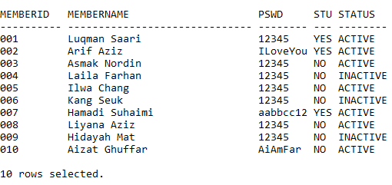

1. **Author table**

Author table is the table that holds all the relevant information of authors that contributes their work to Exodus library. The primary key for this table was the author ID which also generated automatically using trigger and sequence in SQL.

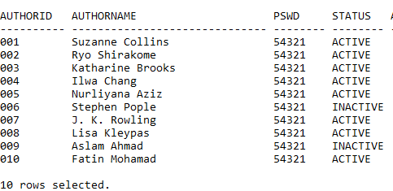

1. **E-Book table**

E-book table is the table that holds all the relevant information of the available books that are contributed by authors and how long they can be subscribed for free. It also has auto generated primary key, the ebook ID, using trigger and sequence in SQL.

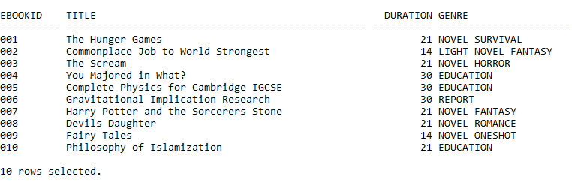

1. **Issue table**

Issue table is the table that connects the members and their subscription of a certain e-books. This table holds all the relevant information of when the e-book was issued to the member and their expiry date. It has its own primary key, which is Issue ID and holds 2 foreign key, member ID and ebook ID.

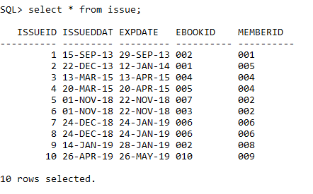

1. **Lent table**

Lent table is the table that connect the authors table and their relevant works in e-book table. This table holds the information of when the author started contributing their works in Exodus library, and how long their work will be available in the library, and their current service type. All of the books will started out as free, and will only change to premium (paid subscription) if the author demands it. This table holds Lent ID as their primary key, and 2 foreign key, the author ID and ebook ID.

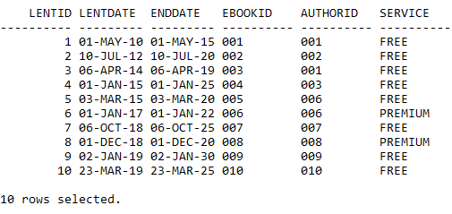

**UPDATE**

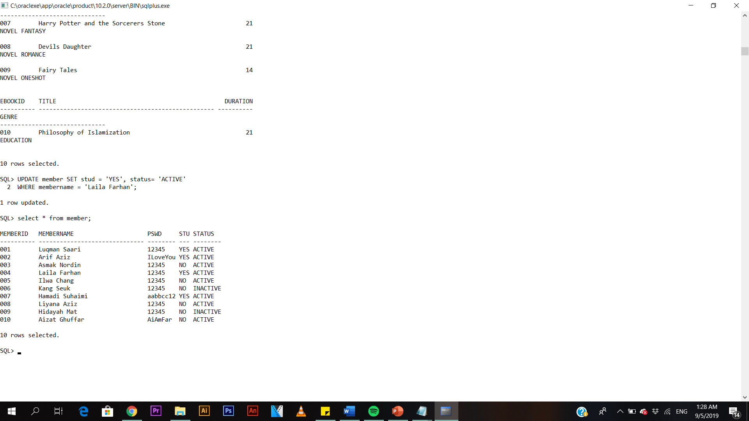

**DELETE**

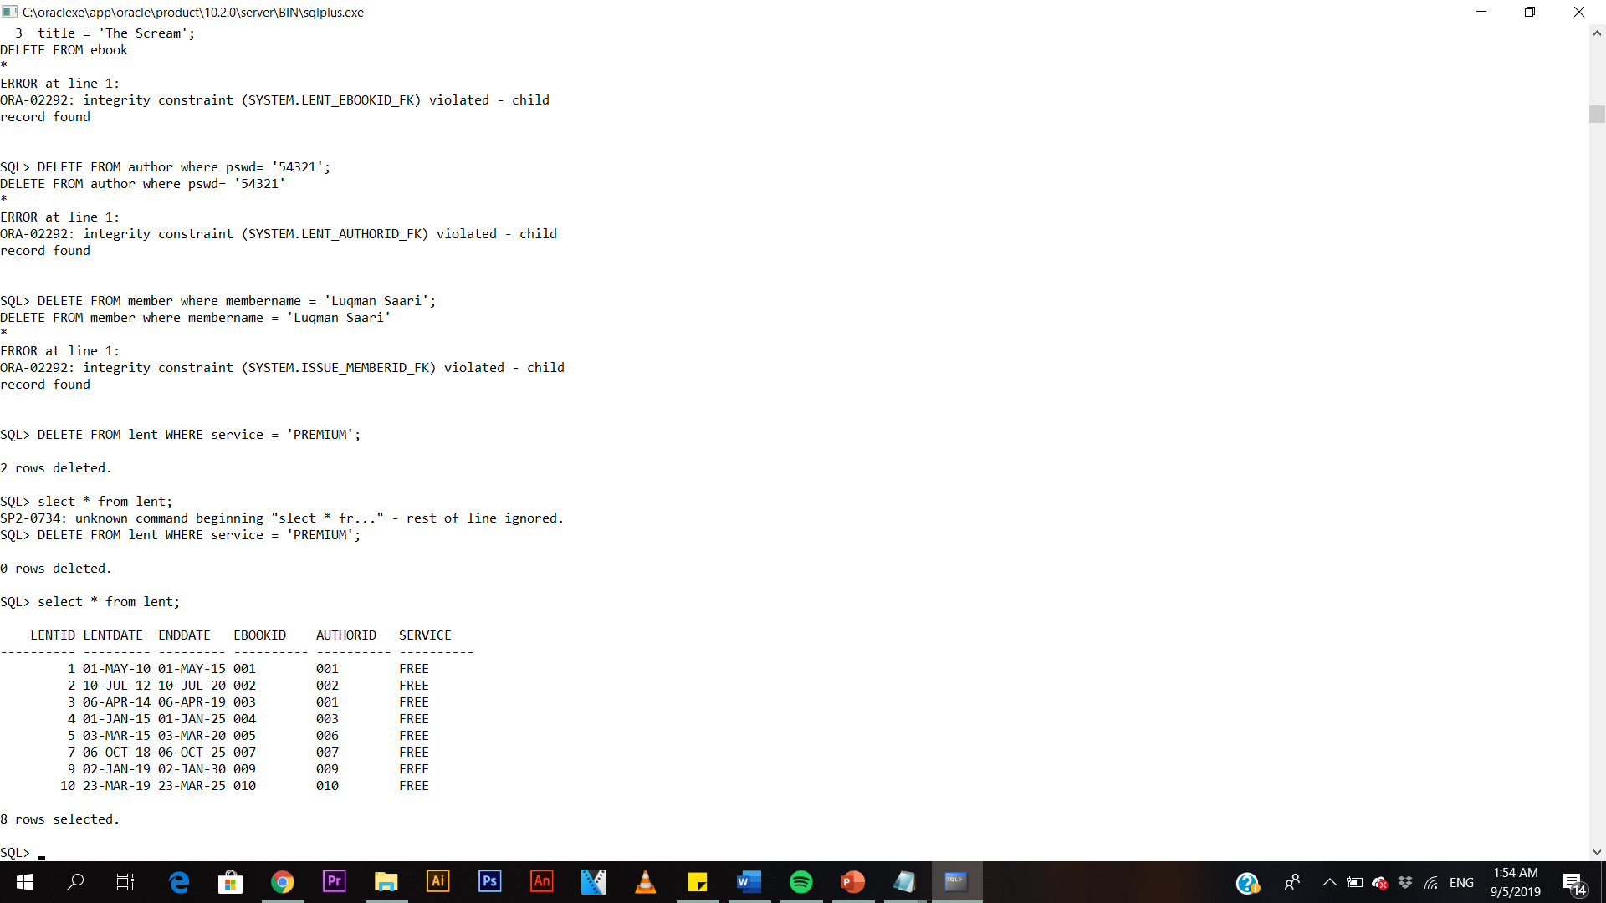



**6.0 Procedure**

**6.1 AddAuthor procedure**

A procedure was created to add any new authors to the library if their records are not in the library database. Since the author ID is automatically generated, we did not need to have any input for author ID.

**Script:**

create or replace procedure AddAuthor(

authorname IN author.authorname%TYPE,

password IN author.pswd%TYPE,

stat IN author.status%TYPE)

IS

BEGIN

INSERT INTO AUTHOR ("AUTHORNAME","PSWD","STATUS")

VALUES(authorname,password,UPPER(stat));

END;

/

**Anonymous Block**

ACCEPT name PROMPT 'Enter the Author name : ';

ACCEPT pasword PROMPT 'Create new password : ';

ACCEPT statuses PROMPT 'Status (ACTIVE/INACTIVE) : ';

BEGIN

AddAuthor('&name','&pasword','&statuses');

END;

/

**6.2 After AddAuthor Procedure**

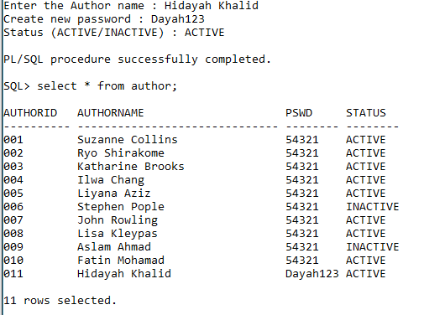

**6.3 AddBook procedure**

AddBook procedure is a procedure created if there is any new e-book available in the Exodus library that are available to the public. The e-book ID will be automatically generated. This procedure needed to be executed before the AddLent procedure.

**Script :**

create or replace procedure AddBook(

btitle IN ebook.title%TYPE,

durations IN ebook.duration%TYPE,

genres IN ebook.genre%TYPE)

IS

BEGIN

INSERT INTO EBOOK ("TITLE","DURATION","GENRE")

VALUES(btitle,durations,UPPER(genres));

END;

/

**Anonymous Block**

ACCEPT title PROMPT 'Enter book title : ';

ACCEPT duration PROMPT 'Max borrow duration : ';

ACCEPT genre PROMPT 'Genre: ';

BEGIN

AddBook('&title','&duration','&genre');

END;

/

**6.4 After AddBook Procedure**

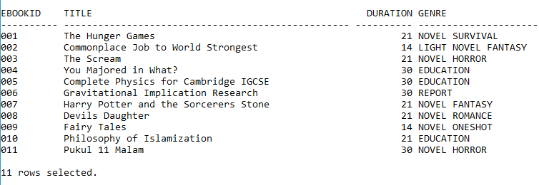

**6.5 AddLent procedure**

AddLent procedure is the most important one since it connects the new books and their respective authors. The Lent ID are automatically generated, however the ebook ID and the author ID must be taken from existing sources in the database, which is why it is important to execute this procedure only after AddBook procedure was executed..

**Script :**

create or replace procedure AddLent(

lent_date IN lent.lentdate%TYPE,

end_date IN lent.enddate%TYPE,

e_bookid IN lent.ebookid%TYPE,

author_id IN lent.authorid%TYPE,

serv IN lent.service%TYPE)

IS

BEGIN

INSERT INTO LENT("LENTDATE", "ENDDATE", "EBOOKID", "AUTHORID","SERVICE")

VALUES (TO_DATE(lent_date), TO_DATE(end_date), e_bookid, author_id, serv);

END;

/

**Anonymous block**

ACCEPT lentdate PROMPT 'Enter lend date : ';

ACCEPT enddate PROMPT 'Enter end lend date : ';

ACCEPT bookid PROMPT 'Enter Book ID : ';

ACCEPT authorid PROMPT 'Enter Author ID : ';

ACCEPT service PROMPT 'Enter service type (FREE/PREMIUM) : ';

BEGIN

AddLent('&lentdate','&enddate','&bookid', '&authorid', '&service');

END;

/

**6.6 After AddLent procedure**

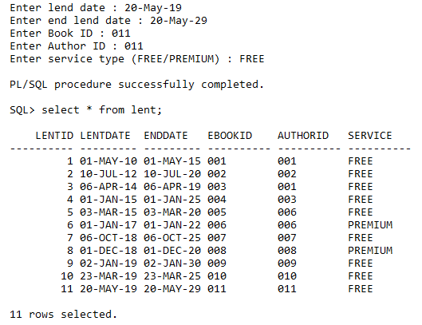

**7.0 Functions**

**7.1 CheckAvailability function**

Check whether the books are available or not. Since every books were contributed for a certain period of time, the member can check first their availability.

**Script :**

CREATE OR REPLACE FUNCTION chkavailable_sf(id IN VARCHAR2) RETURN NUMBER IS

validation NUMBER;

startdate DATE;

finishdate DATE;

BEGIN

BEGIN

SELECT lentdate, enddate

INTO startdate, finishdate

FROM lent

WHERE ebookid = id;

IF SYSDATE > startdate AND SYSDATE < finishdate THEN

validation := 1;

ELSE

validation := 0;

END IF;

EXCEPTION

WHEN NO_DATA_FOUND THEN

validation := 0;

END;

RETURN (validation);

END chkavailable_sf;

/

**Anonymous block**

ACCEPT val PROMPT 'Enter the E-Book ID: ';

DECLARE

bookid VARCHAR2(10) := '&val';

validation NUMBER;

vtitle ebook.title%TYPE;

BEGIN

validation := chkavailable_sf(bookid);

SELECT title

INTO vtitle

FROM ebook

WHERE ebookid = bookid;

IF validation = 1 THEN

DBMS_OUTPUT.PUT_LINE('Requested book: ' || vtitle || ' (' || bookid ||') | Status: AVAILABLE');

ELSE

DBMS_OUTPUT.PUT_LINE('Requested book: ' || vtitle || ' (' || bookid ||') | Status: UNAVAILABLE');

END IF;

END;

/

**Example** :

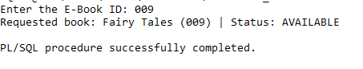

**7.2 Check Expired Date fucntion**

Check whether the books are available or not. Since every books were contributed for a certain period of time, the member can check first their availability.

**Script :**

CREATE OR REPLACE FUNCTION getexpdate_sf (id in VARCHAR2) RETURN DATE IS

issueperiod ebook.duration%TYPE;

expdate DATE;

BEGIN

SELECT duration

INTO issueperiod

FROM ebook

WHERE ebookid = id;

expdate := (SYSDATE + issueperiod);

RETURN (expdate);

END getexpdate_sf;

/

**Anonymous block**

ACCEPT val PROMPT 'Enter the E-Book ID: ';

DECLARE

ebookid VARCHAR2(10) := '&val';

expireddate DATE;

BEGIN

expireddate := getexpdate_sf(ebookid);

DBMS_OUTPUT.PUT_LINE('EXPIRED DATE FOR THE ISSUE IS: ' || expireddate);

END;

/

**Example :**

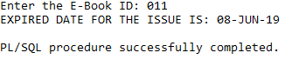

**8.0 Conclusion and future improvements**

The world is changing towards digital and informational age. We are moving faster and faster towards virtual world while slowly eliminating the needs of physical items. Whenever there is change, the generation of people who lives in it, will often demand changes and simplicity to do things. This virtual and digital library is a perfect example of a platform that are in need in these current age. Applying simplicity along with ease of access, high mobility platform and wide availability will raise the demands of Exodus library. Be that as it may, there are still few improvements that we can instill for our Exodus.

**8.1 Graphical User Interface (GUI)**

An interface designed to be user-friendly and neat can bring out the best quality of our library. A GUI designed with simplicity yet highly functional features will be the bread and butter for Exodus. This will allow an execution of process to be done smoothly, thus attracting more members to try and explore Exodus as a new digital library platform.

**8.2 Multiple platform accessibility**

Exodus also needs to keep up with the rapid changes with the modernization of the current age. Connection Exodus database into multiple Internet of Things (IoT) platform will boost the accessibility exponentially. Device like tablets and smartphones are a must platform to have since it is a basic platform in the current age, however embedding Exodus into a platform like public transportation such as trains or flights, or personal transportation such as smart car or automobile will also maximize the mobility and accessibility of Exodus as a digital library. This will truly allow people to invest in reading books, almost anywhere and everywhere.

All in all, Exodus still have plenty of room to be improved and have the value to be commercialized as a product that can truly bring joy, ease and changes in the world of reading with the spirit of Iqra’ as its core.